# **Задания**

## **Задача 1:**

### **Работа программы:**

1

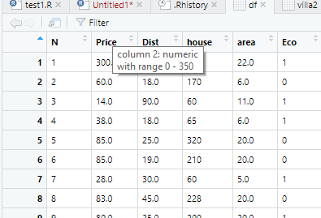

2

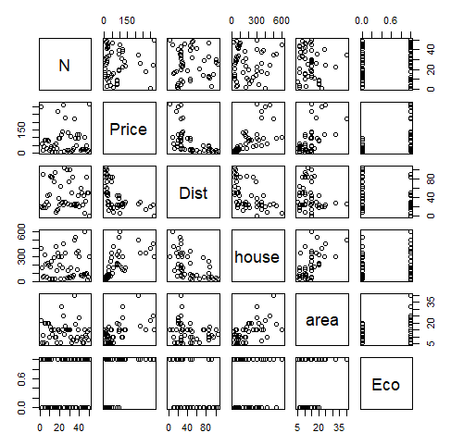

3

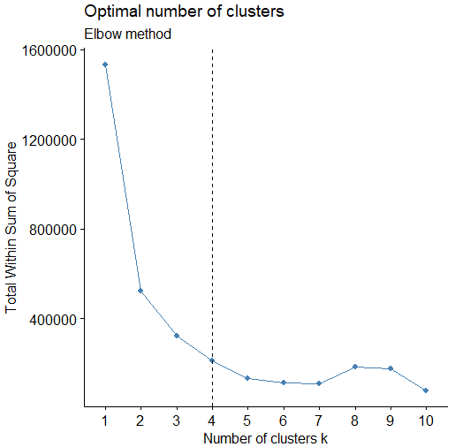

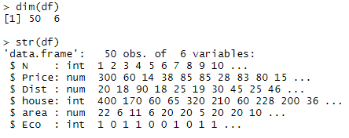

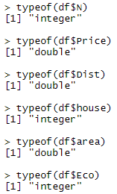

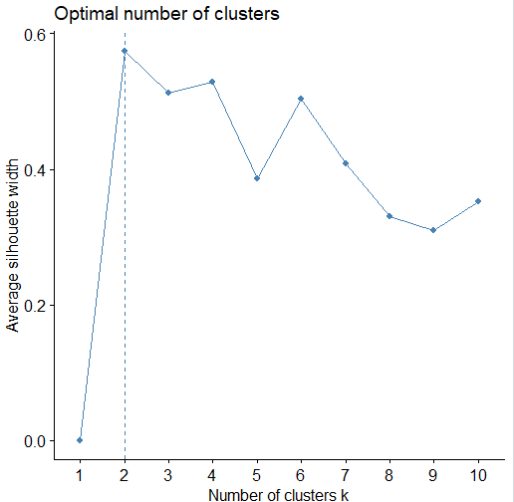

4

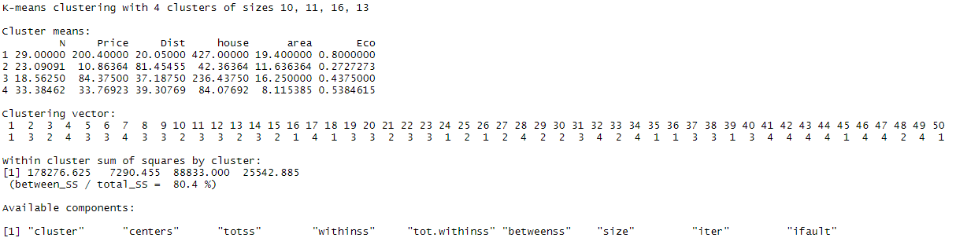

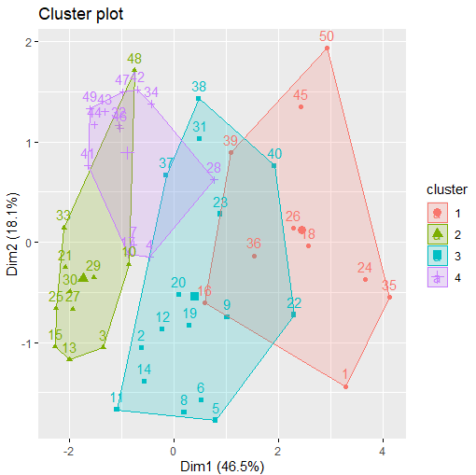

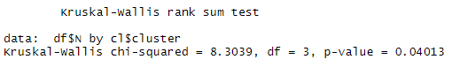

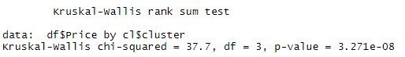

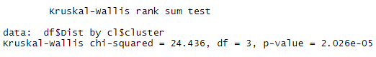

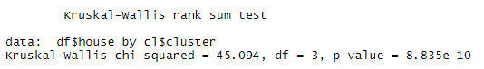

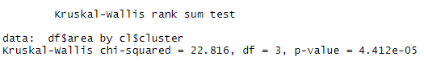

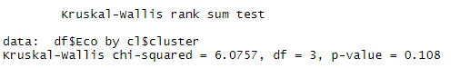

Гипотезу о различии распределения по кластерам отвергаем, тк p-value близко к 0

### **Листинг:**

#install.packages(c("factoextra"))

library(readr)

library(factoextra)

df <- read_delim("villa2.csv", ";", escape_double = FALSE, locale = locale(decimal_mark = ","), trim_ws = TRUE)

View(df)

plot(df)

df <- read.csv(file = "villa2.csv", sep = ";")

st <- as.vector(df$area);n <- gsub(",", ".", st);n <- as.numeric(n);df$area <- n

st <- as.vector(df$Price);n <- gsub(",", ".", st);n <- as.numeric(n);df$Price <- n

st <- as.vector(df$Dist);n <- gsub(",", ".", st);n <- as.numeric(n);df$Dist <- n

dim(df)

str(df)

typeof(df$N)

typeof(df$Price)

typeof(df$Dist)

typeof(df$house)

typeof(df$area)

typeof(df$Eco)

df <- na.omit(df)

fviz_nbclust(df, kmeans, method = "wss") + labs(subtitle = "Elbow method") + geom_vline(xintercept = 4, linetype = 2)

fviz_nbclust(df, kmeans, method = "silhouette")

fviz_cluster(kmeans(df, 4), data = df, ellipse.type = 'convex')

kruskal.test(df$N ~ cl$cluster)

kruskal.test(df$Price ~ cl$cluster)

kruskal.test(df$Dist ~ cl$cluster)

kruskal.test(df$house ~ cl$cluster)

kruskal.test(df$area ~ cl$cluster)

kruskal.test(df$Eco ~ cl$cluster)